Start Sheet

Event Secretary Mark Gidney (Southborough & District Wheelers)
28 Chantlers Mead, Cowden, Kent, TH8 7HU
Tel: 01342 851 255; 07775 024 661
ESCA 100 Mile TT
Awards
Fastest
First | £30.00
Second | £20.00
Highest Vet on Std
First | £20.00
Second | £11.00
Fastest Woman
First | £30.00
Second | £20.00

Email: markgidney2002@hotmail.com

Timekeeper Mr. Doug Finch (Southborough & District Wheelers)

General Information
Event HQ: Upper Dicker Village Hall, Coldharbour Road, Upper Dicker, East Sussex BN27 3QE.

From A27: follow Berwick Station signs at Alfriston roundabout. Straight on for 4 miles. Hall is on Right at end of village.

From A22: half mile West of Boship Roundabout, Lower Dicker. Turn into Coldharbour Road (at the 'Metamorphosis' Bathroom Centre). Hall is on Left after 1 mile; after '40' and 'Upper Dicker' sign.

The hall will be open from 5:00am for changing. Limited free refreshments will be on offer after the event

Car Parking: There is ample parking in the field at the rear of the village hall where you will find entry doors to the hall and facilities. The car park entrance is the gate next to the HQ - please drive around the football pitch and park directly behind the hall. Please do not park on the football pitch or block the entry/exit route.

Race Numbers: Numbers will be available at the event HQ. Please collect your number when you sign on. After the event all riders must sign out and return race numbers at the HQ.

Start: LEFT out of HQ; LEFT at staggered X-roads; LEFT at grass triangle; continue almost to A22. The start is 2 miles from the HQ. Please allow at least 10 minutes getting to the start.

This is a qualifying event for
ESCA Points Competition: 30 points for 1st place down to 1 point for 30th place for riders from an ESCA affiliated club. The individual points earned by each rider are totalled and awarded to their respective club.

ESCA Trophies: The fastest rider from an ESCA affiliated club will be awarded the 100m Cup, and the fastest team of three riders from an ESCA affiliated club will be awarded the 100m Team Shield at the annual prize presentation.

ESCA BAR: Qualifying event for the Senior and Veteran BAR competitions.

SCA and KCA BAR: Qualifying event for the long-distance BAR

BBAR: Qualifying event for the British Best All Rounder competition.

Sussex SPOCO: Long distance qualifying event – 120 points for 1st place down to 1 point for 120th place for first claim riders from Sussex CA affiliated clubs.

VTTA Surrey/Sussex Group: The member with the highest plus against standard will be awarded a medal at the group’s prize presentation lunch.
Course Details – G100/861

Map attached, courtesy of SCA; available at: http://www.sussexca.org.uk/g100861.html .

START at eastern end of Arlington Road West opposite Give Way Sign just before junction with A22 northbound carriageway
LEFT and follow A22 via Diplocks Way RBT to Boship RBT

Start of LAP 1
LEFT 1st Exit to on A22 to junction with B2124 at Golden Cross.

LEFT on B2124 to TURN at Ringmer, Kennel Corner RBT (9.1 MILES).

RETRACE to A22 at Golden Cross.

LEFT on A22 via The Shaw RBT, Halland RBT, Golf Course RBT, Little Horsted RBT (19.9 MILES) Copwood RBT, Owlsbury RBT to

TURN at Black Down RBT (A22/A26 split here). (22.8 MILES).

RETRACE on A22 via Copwood, Owlsbury, Little Horsted, Golf Course, Little Horsted, Halland and The Shaw Roundabouts to Boship RBT.

TURN 4th Exit to A22.

This completes LAP 1. (34.1 MILES)

REPEAT Boship - Golden Cross – Ringmer – Golden Cross – Black Down – Boship.
This completes LAP 2. (66.5 MILES).

REPEAT Boship - Golden Cross – Ringmer – Golden Cross – Black Down – Boship.
This completes LAP 3. (98.8 MILES).

RETRACE on A22 to Coldharbour Road (at 'Metamorphosis bathroom showroom)
LEFT along Coldharbour Road to FINISH at White paint mark just past April Cottage, 93 yards before 40 mph 346 yards before front door of Dicker Village Hall (100.0 MILES)

Additional Hazards The new Owlsbury roundabout TAKE CARE in negotiating the new roundabout between Copwood RBT and Little Horsted RBT

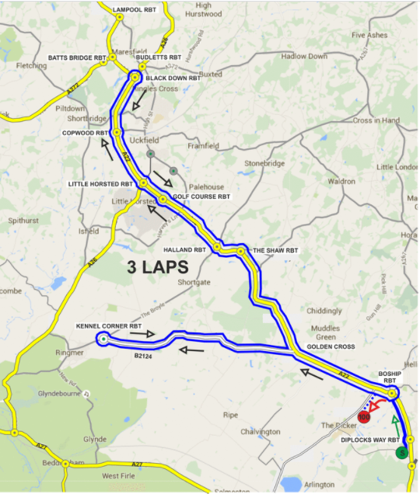
New Owlsbury Roundabout

Please note the following CTT regulations and recommendations

Helmets CTT regulations now require the use of a helmet that meets internationally accepted safety standards for all competitors. NOTE THIS IS A NEW REGULATION FOR 2022
Lights CTT Regulations now require that no competitor shall be permitted to start either a Type A or Type B event unless such competitor has affixed to the rear of their machine a working rear red light, and to the front of their machine a working front white light, either flashing or constant, that are illuminated and positioned to be clearly visible to other road users. NOTE THIS IS A NEW REGULATION FOR 2022

Competitors’ Machines: It is recommended that a working rear light, either flashing or constant, is fitted to the machine in a position clearly visible to following road users and is active while the machine is in use.

Competitors’ Vehicles: No vehicles, except those of timekeepers and event officials, shall be parked in the vicinity of the start or finish.

Safety Instructions: Details of any additional hazards not listed on the start sheet will be displayed at the signing on point. Competitors must exercise extra care when negotiating all roundabouts.

Warming Up: Competitors are requested not to warm up on the course after the event has started.

Race Numbers: The race number is made of fluorescent material which is an important safety feature. It is essential that it is placed correctly for maximum visibility to other road users and of course the timekeepers. Please pin your number here

Results: No times will be given out at the finish.

Riders Be Aware: Generally the road is in good repair. However there are some sections where care must be taken with heads up to look out for pot holes and some cracks that could cause impact punctures if hit hard.

Signing Out: Please note that all competitors are now required personally to sign the signing-out sheet when returning their number. In accordance with CTT regulations, failure to do so will result in the competitor being recorded as DNF.

NO FRONT & REAR LIGHTS & HELMET = NO RIDE!!!!

Start Time | Number | First Name | Last Name | Club | Gender | Category
06:01 | 1 | Chris | Parker | Hastings & St. Leonards CC | Male | Veteran
06:02 | 2 | Glenda | Goscomb | 7Oaks Tri Club | Female | Veteran
06:03 | 3 | Kate | Thomas | Lewes Wanderers CC | Female | Veteran
06:04 | 4 | Paul | Tippett | Crawley Wheelers | Male | Veteran
06:05 | 5 | David | Pollard | VTTA (Surrey/ Sussex) | Male | Veteran
06:06 | 6 | Peter | Baker | Lewes Wanderers CC | Male | Veteran
06:07 | 7 | Sean | Yates | Team Solo Vinci | Male | Veteran
06:08 | 8 | Gareth | Purves | Hastings & St. Leonards CC | Male | Veteran
06:09 | 9 | Duncan | Fuller | Lewes Wanderers CC | Male | Veteran
06:10 | 10 | David | Greenwood | Rye & District Wheelers CC | Male | Veteran
06:11 | 11 | Keith | Garbutt | South Western Road Club | Male | Veteran
06:12 | 12 | James | Harris | Catford CC Ltd | Male | Veteran
06:13 | 13 | Michael | Gates | C and N Cycles RT | Male | Senior
06:14 | 14 | Adam | Rogers | Eastbourne Rovers CC | Male | Veteran
06:15 | 15 | Gavin | Richards | Lewes Wanderers CC | Male | Veteran
06:16 | 16 | Paul | Thatcher | Brighton Mitre CC | Male | Veteran
06:17 | 17 | Glen | Whittington | Southborough & Dist. Whs | Male | Senior
06:18 | 18 | Richard | Tully | Elite Cycling | Male | Veteran
06:19 | 19 | Anita | Turner | Eastbourne Rovers CC | Female | Veteran
06:20 | 20 | Lisa | Davis | DRAG2ZERO | Female | Veteran
06:21 | 21 | Pip | Jenkins | 1904RT | Female | Senior
06:22 | 22 | Malcolm | Cox | Velo Club St Raphael | Male | Veteran
06:23 | 23 | Martin | Brown | 7Oaks Tri Club | Male | Veteran
06:24 | 24 | Nathan | Russell | trainSharp | Male | Senior
06:25 | 25 | Andrew | Rivett | Velo Club St Raphael | Male | Veteran
06:26 | 26 | Sam | Fuller | Southborough & Dist. Whs | Male | Senior
06:27 | 27 | Pat | Wright | Paceline RT | Male | Senior
06:28 | 28 | Christopher | McNamara | Nuun-Sigma Sport-London RT | Male | Veteran
06:29 | 29 | Kevin | Baumber | Shaftesbury CC | Male | Veteran
06:30 | 30 | Leon | Marshall | Royal Navy & Royal Marines CA | Male | Veteran

